Model Development Phase Template

|  |  |
| --- | --- |
| Date | 03 October 2024 |
| Team ID | LTVIP2024TMID24947 |
| Project Title | SmartLender - Applicant Credibility Prediction for Loan Approval |
| Maximum Marks | 4 Marks |

# Initial Model Training Code, Model Validation and Evaluation Report

The initial model training code will be showcased in the future through a screenshot. The model validation and evaluation report will include classification reports, accuracy, and confusion matrices for multiple models, presented through respective screenshots.

# Initial Model Training Code:

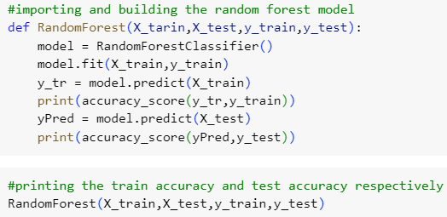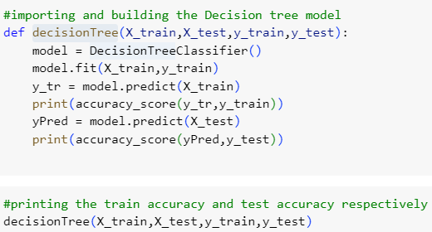

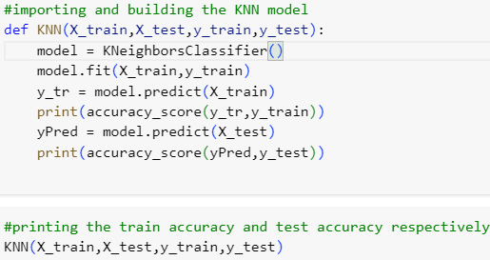

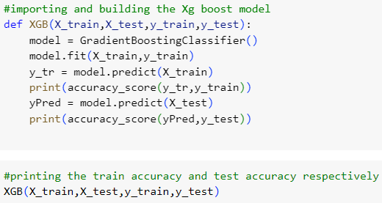

**Model Validation and Evaluation Report:**

|  |  |  |  |
| --- | --- | --- | --- |
| **Model** | **Classification Report** | **F1**  **Scor e** | **Confusion Matrix** |
| Random Forest |  | 98% |  |

|  |  |  |  |
| --- | --- | --- | --- |
| Decision Tree |  | 98% |  |
| KNN |  | 92% |  |
| Gradient Boosting |  | 98% |  |